Asia-Pacific
Broadcasting Union

May 2005

ABU Technical Department

RNZ -ABU Technical Investigations on Digital Radio in Medium Wave Band Wellington (April, 2005)

A project has been set up in Wellington by Radio New Zealand in collaboration with the ABU, Thales Corp, BBC, Deutsche Welle and THL-Australia to carryout technical investigations on digital radio transmissions in the medium wave band using the DRM digital system. A three day symposium was also organized at RNZ office in Wellington as a part of this activity. This is the second such event the ABU has been involved in, the other being the Digital Radio Showcase in Bangkok in May 2004.

An analogue medium wave radio transmitter of RNZ was converted for digital transmissions and technical investigations on the digital transmissions were carried out. Of utmost interest to us among the investigations are those pertaining to simulcasting.

Medium Wave Markets
Many medium wave radio markets in the Asia-Pacific operate in a competitive environment and radio broadcasters are reluctant to consider making any technology changes. It is their apprehension that such a change might disturb their revenue streams. Therefore, any strategy for introduction of digital radio in this band would have to ensure continuity of the on-going services.

Simulcasting
Simulcasting is a technique which permits simultaneous transmission of analogue and digital radio programmes generally in the same radio channel. This provides the listeners with an opportunity to receive digital programmes, without pre-empting reception of the analogue programmes. Simulcasting is an immensely useful technique for facilitating seamless entry of digital services without having to displace analogue services. Of necessity, both analogue and digital programmes need to be downgraded before transmission so as to permit their accommodation in the same channel. Therefore simulcasting is useful only as an interim measure.

The ABU perceives simulcasting in the medium wave as a feasible way of introducing digital radio in the medium wave band. Experiments on medium wave simulcasting were attempted for the first time in this region. We do have the advantage of having wider medium wave channels (18 kHz), double that of the European and African countries. This feature may make this region more suitable for simulcasting.

Symposium

The Digital Radio Symposium and Demonstration (27-29 April, 2005) was inaugurated by Mr Peter Cavanagh CEO of Radio New Zealand. Around 70 radio experts from ABU members and others in the radio industry participated in this event which exposed them to technical intricacies of digital radio and conversion of transmitters to digital operation. The participants also witnessed measurements on various technical parameters. A field measurement trip took place 29 April on which measurements were taken at about 30 KMs far from the transmitter.

The measurements are continuing. Results of this investigation will help determine appropriate digital radio implementation strategies for radio broadcasters.

Annex to this report analyses the implications of simulcasting.

Annex

Simulcasting in Medium Wave Band in Region 3

As an outcome of the deliberations at the Symposium, the following issues emerged on simulcasting.

Channel width and spacing in ITU-R Region 3 (Asia-Pacific)
This region has 18 kHz wide channels following a 9 kHz channel raster, depicted below.

Channel 1 | Channel 2
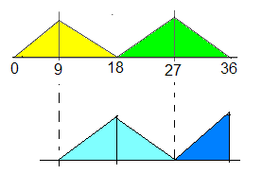 |  | Location 1
 |  | Location 2

Possible Modes for Simulcasting
Some of the practicable simulcasting modes are:

1. Analogue 9 kHz, Digital 4.5 kHz

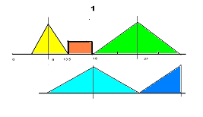 | Location 1  Digital
 | Location 2

2. Analogue 9 kHz, Digital 2 x 4.5 kHz

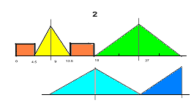 | Location 1
 | Location 2

If this mode is used, the two digital blocks cannot carry the same digital service. The reason is that the digital receiver is not equipped to decode the separated blocks simultaneously.

3. Analogue 9 kHz, Digital 9 kHz

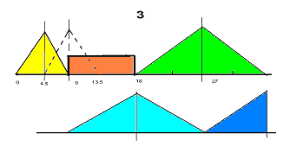 | Location 1
 | Location 2

Full Digital 18 kHz
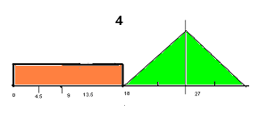

Analysis
Modes 1 and 3 seem to be more practicable although these still have the following drawbacks:

- White noise (hiss) comes up in analogue radio receivers with a wider pass filter (say more than 9 kHz). This is due to the digital carrier adjacent to the analogue carrier. Most radio sets in the market are reported to have narrow filters and are not significantly affected as long as the power of the digital component is reduced to an appropriate level (see point 6).
- DRM receivers do not seem to be affected by the analogue signal. This needs to be quantified.
- While mode 3 could have been an acceptable option, there is a major drawback – the centre frequency of the analogue carrier has to be shifted by 4.5 kHz.
- Centre frequency shifting will have a major impact on the planning structure of the ITU GE- 75 medium wave plan. There does not seem to be any such provision in GE-75 to implement this. It is to be expected that several major users of the medium wave band in the region will strongly oppose any shifting of the centre frequency.
- Mode 2 may seem to be a practicable option. However, there is a drawback that currently the DRM digital receiver is not equipped to decode the separated blocks simultaneously. Also a frequency shift of 500 Hz would be required to be made in the second digital block to agree with the current DRM algorithm.
- Power levels of the simulcast digital signals have to be determined keeping in view analogue transmission on the adjacent channel and the co-channel (Location 2) during night time. This is expected to reduce digital power levels significantly.
- Power levels of the simulcast digital signals have also to be determined vis-à-vis power level of the analogue transmission. For example in mode 3 (above), the digital power level may be around 16 dB below the peak analogue carrier.
- It may be useful to keep a buffer of about 500 Hz between the analogue and digital segments.

Discussion
1. Use of one 18 kHz channel for simulcasting, while providing adequate band width, significantly limits the power levels of the digital signal. For example, in mode 3 (9 kHz digital), the digital power level may be around 16 dB below the peak analogue carrier. This is to be expected as the two carriers share the same transmitter. This really means that apart from limitations of hiss, the digital coverage would be very limited as compared to the analogue coverage. Given the higher probability of signal availability required for digital reception, the digital coverage would indeed be far less as compared to the analogue coverage.

2. The situation in mode 1 would be quite similar, if not worse. In addition, signal quality (bit rate affordable) in mode 1 would also be limited, given that the bandwidth is only 4.5 kHz.

3. Therefore, none of the above three modes seem to be appropriate for practical simulcast coverage.

- It may be concluded that using 18 kHz channels for simulcasting is not necessarily an advantage. It could be advocated that in Region 3 two adjacent channels be used for simulcasting, as is being mooted for Region 1.
- It could be argued that mode 2 could be the best available option. It would also help if 500 Hz “guard bands” are inserted between the digital and the analogue blocks. If that be the case, the DRM specifications would require to be revised.
- For coverage purposes, if 66 dBu is considered to be analogue field strength limit and 40 dBu the digital limit, then the two simulcast coverage contours would match - assuming the digital power is reduced by 16 dB. However, the analogue coverage limit is considered to be lower, the analogue coverage will exceed the digital coverage. It is also to be kept in view that probability of digital signal availability required for satisfactory reception is much higher than that required for analogue coverage.
- Another message that needs to be sent out to the receiver manufacturers is to include the 18 kHz all digital feature in their future receiver designs.

Sharad Sadhu
ABU _____________

