

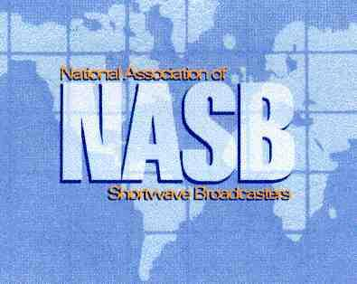

February 16, 2009

Dear Colleagues:

The Steering Board of the HFCC/ASBU in cooperation with the National Association of Shortwave Broadcasters (NASB) and a series of local co-sponsors have the pleasure of inviting you to the B09 Season Coordinating Conference to be held in the Dominican Republic between August 17 and 21, 2009.

The Conference will be held at the Dreams Punta Cana Resort on the east coast of the Dominican Republic. Delegates are requested to arrange their accommodation using the registration and hotel booking form, which can be found on the HFCC web page for the B09 Conference.

All delegates are strongly urged to send their registration forms to the NASB Secretariat office as soon as possible – and by June 17, 2009 at the very latest.

The registration cost is 150 Euros per delegate, or equivalent in US dollars. This fee, as well as transportation fees between the airport and hotel, will be collected by the Conference Secretariat on Sunday, August 15 and Monday morning, August 16. Payment should be made in cash.

We look forward to your participation in the B09 HFCC/ASBU Coordination Conference.

Oldrich Cip. Chairman Jeff White
HFCC/ASBU Steering Board President, NASB

